Import the "PCA9685.py" library file.
The default directory where Mu saves files is "Mu_code", which is located in the root directory of the user directory. Reference link: https://codewith.mu/en/tutorials/1.0/files

For example, in the windows system, suppose your system is installed on the C drive of the computer, and the user name is "Administrator", then the path of the "mu_code" directory is "C:\Users\Administrator\mu_ code". On Linux systems, the path of the "mu_code" directory is "~/home/mu_code".

Enter the “mu_code”folder.
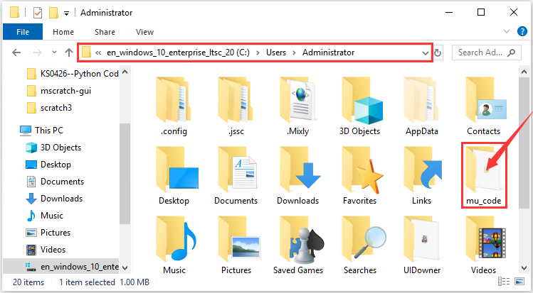

Copy“PCA9685.py“library file to folder”mu_code“
When the copy is done, it should be look like this:
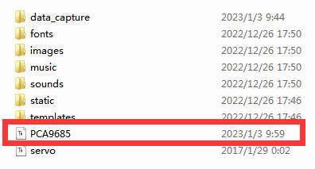

First open the Mu software and connect the micro:bit to your computer, then click the "Files" , and then drag the "PCA9685.py" library file to micro:bit.
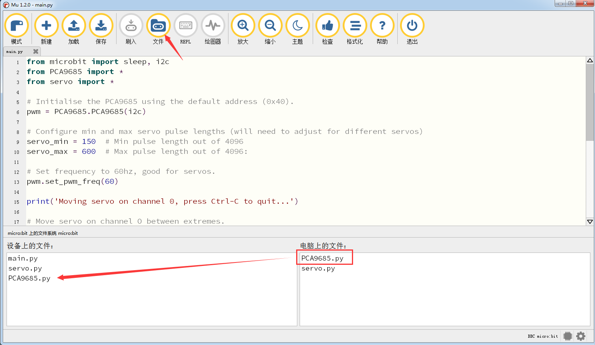

After a few seconds, the import is complete and you can see it in the box on the left.
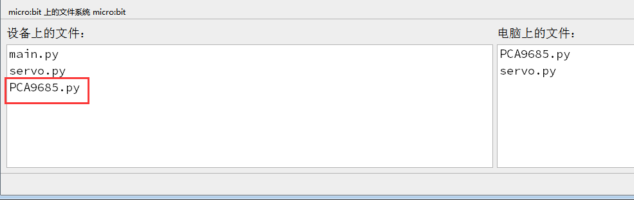

After the library file is imported successfully, you also need to click the "Check" button to check the code for errors. If a cursor or an underline appears on a certain line, it indicates that there is an error in the program.
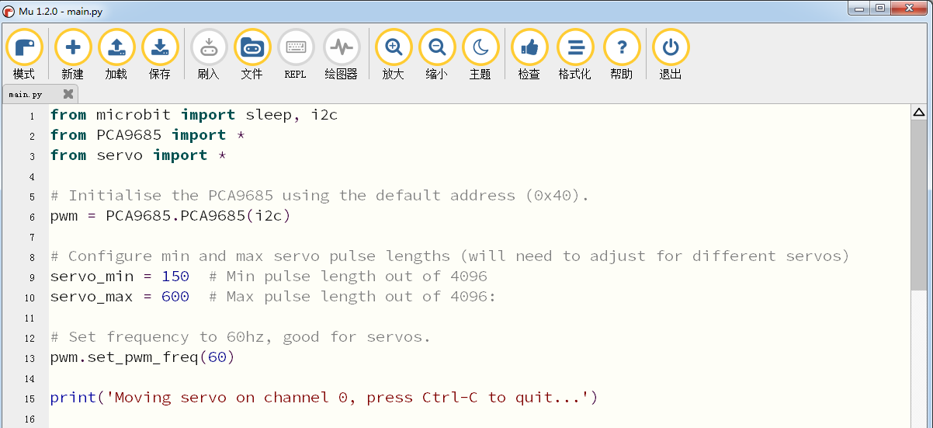

However, during this process, the following prompt will appear even if there is no error in the code. These prompts are just warnings, not code error prompts. In other words, the entire code is error-free.

If the code is correct, connect micro:bit to computer and click“Flash”to download code to micro:bit board.
